

**MARKETING RESEARCH ON**

**"Analyzing Customer Perception of Skechers: A Survey-Based Study”**



By :Priya Ranjan Kr.  
 Github : [Priya-Ranjan-Kr · GitHub](https://github.com/Priya-Ranjan-Kr)

LinkedIn: [Priya Ranjan Kumar |LinkedIn](https://www.linkedin.com/in/pranjankr/)

**TABLE OF CONTENTS**

* RESEARCH OBJECTIVES AND QUESTIONS…………………………………………….3
* RESEARCH DESIGN… ….4
* CHI-SQUARE TEST………………………………………………………………………....4
* ANOVA… ………6
* CORRELATION………………………………………………………………………………7
* SIMPLE REGRESSION ANALYSIS… …..10
* MULTIPLE REGRESSION ANALYSIS… …..11
* FACTOR ANALYSIS………………………………………………………………………...13
* CLUSTER ANALYSIS……………………………………………………………………….15



**RESEARCH OBJECTIVES AND QUESTIONS**

RESEARCH OBJECTIVE 1: To identify factors influencing customer loyalty towards Skechers.

Research Question 1**:** What specific aspects of Skechers products or services contribute to customer loyalty?

Research Question 2**:** How frequently do customers return to Skechers for their sporting goods needs?

RESEARCH OBJECTIVE 2: To evaluate customer perceptions of the quality of Skechers products.

Research Question **:** What factors contribute to positive or negative perceptions of Skechers product quality?

**RESEARCH DESIGN**

|  |  |
| --- | --- |
| **PARADIGM** | **POSITIVIST** |
| **RESEARCH DESIGN** | **DESCRIPTIVE** |
| **UNIT OF ANALYSIS** | **People owned/owning Skechers Products** |
| **POPULATION** | **People interested in Athletics** |
| **SAMPLING FRAME** | **People owned/owning Skechers Products** |
| **SAMPLING TECHNIQUE** | **STRATIFIED/CLUSTER** |
| **DATA COLLECTION METHOD** | **PRIMARY(SURVEY)** |
| **RESEARCH INSTRUMENT** | **QUESTIONNAIRE** |
| **SAMPLE SIZE** | **72** |

**CHI-SQUARE TEST**

Test of Association between two categorical variables

Testing whether age group and frequency of purchase are dependent or independent of each other.

Variable 1- Age Group

Variable 2-How often do you make purchases at Skechers for your sporting goods needs?

**Null Hypothesis-** Age group and Frequency of Purchase are independent of each other, proportions of the populations are the same

**Alternate Hypothesis-**Frequency of Purchase is Dependent on Age Group, proportions of populations are different.

**Rejection Rule-**Reject the null hypothesis when chi-square calculated is greater than chi-square critical or p-value is less than alpha.

Assume Alpha is 0.05

After conducting chi-square test using R-studio

Pearson's Chi-squared test

data: Purchase

X-squared = 21.702, df = 9, p-value = 0.009873

P-value = 0.009873

As P-value<Alpha (0.009873<0.05) We Reject Null hypothesis

Therefore, Frequency of Purchase is dependent on Age Group.

# ANOVA

Test of significance of difference among more than two populations or sample means

Does product quality rating depend on frequency of exercise? The assumption here is that the more a person exercises the more they will be able to gauge the quality of the product. However, if they do not use the product, they will not be able to understand the product quality.

Independent variable-Frequency of Exercise (Categorical Variable-Daily, Weekly, Monthly, Rarely, Never) (in SPSS V16)

Dependent Variable-Product Quality Rating (Continuous Variable) (V11)

**Null Hypothesis**- Product Quality Rating is Not Dependent on Frequency of Exercise, there is no difference in mean rating of product quality for the different frequencies of exercise.

**Alternate Hypothesis**-Product Quality Rating is Dependent on Frequency of Exercise, here is a difference in mean rating of product quality for the different frequencies of exercise.

**Rejection Rule-** Reject Null Hypothesis when F calculated is greater than F critical value or P-value is less than Alpha

Assume alpha = 0.05

After conducting ANOVA in SPSS P-value = 0.006, F Calculated = 3.95

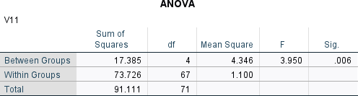

As P-Value<Alpha (0.006<0.05) We reject the null hypothesis

Therefore, there is a significant difference in mean rating of product quality for different frequency of exercise.

# CORRELATION

Test of measuring strength, direction of a relationship between two variables and if that relationship is significant.

# Pearson’s Product Moment Correlation

How are materials used and product design related in determining perception towards product quality? If Skechers wants to create quality products, is there a relationship between materials used and product design?

Variable 1-Product Design (V5)-Please rate the following factors in terms of their impact on your perception of Skechers product quality (Scale: 1 to 5, where 1 is very low impact and 5 is very high impact): - Product Design

Variable 2-Materials Used (V6)-Please rate the following factors in terms of their impact on your perception of Skechers product quality (Scale: 1 to 5, where 1 is very low impact and 5 is very high impact): - Materials Used

**Null Hypothesis-**There is no significant correlation between Product Design and Materials Used in creating a perception of quality product.

**Alternate Hypothesis-**There is a significant correlation between product design and materials used in creating a perception of quality product.

**Rejection Rule-**Reject Null Hypothesis is P-value is less than alpha

Assume alpha = 0.05

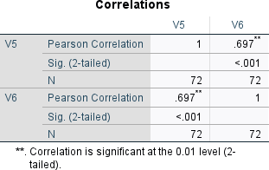

As P-value is less than alpha (0.00<0.05) correlation is significant Correlation coefficient is 0.697

This implies that there is a strong, positive significant correlation between product design and materials used in creating a perception of quality product.

# Partial Correlation

Brand Reputation may create a spurious correlation between materials used and product design as people may believe that a good brand will always have good materials and good product design while a brand with bad reputation will use low quality materials and weak product design. Therefore if people believe that Skechers has a good brand reputation then they may believe that they will use good materials and have good product design inevitably.

Now when conducting partial correlation analysis-

Variable 1-Product Design (V5)-Please rate the following factors in terms of their impact on your perception of Skechers product quality (Scale: 1 to 5, where 1 is very low impact and 5 is very high impact): - Product Design

Variable 2-Materials Used (V6)-Please rate the following factors in terms of their impact on your perception of Skechers product quality (Scale: 1 to 5, where 1 is very low impact and 5 is very high impact): - Materials Used

Spurious Variable-Brand Reputation (V7)-Please rate the following factors in terms of their impact on your perception of Skechers product quality (Scale: 1 to 5, where 1 is very low impact and 5 is very high impact): - Brand Reputation

**Null Hypothesis-**There is no significant relationship between product design and materials used after controlling for brand reputation in determining the perception that Skechers has a good quality product.

**Alternate Hypothesis-**There is a significant relationship between product design and materials used after controlling for brand reputation in determining the perception that Skechers has a good quality product.

**Rejection Rule-**Reject Null Hypothesis is P-value is less than alpha Assume alpha = 0.05

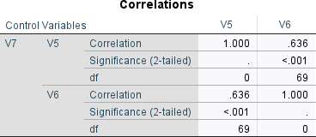

As P-value is less than alpha (0.00<0.05) correlation is significant Correlation coefficient is 0.636

This implies that there is a strong, positive significant correlation between product design and materials used in creating a perception of quality product even after controlling for brand reputation.

# REGRESSION ANALYSIS

1. Determines whether independent variable/variables explain significant variance in dependent variables.
2. Determines how much of the variance in the dependent variable is explained by the independent variable/variables
3. Determines Structure and form of relationship between independent and dependent variables.
4. Can be used to predict or forecast values of dependent variables

# SIMPLE REGRESSION ANALYSIS

Does perception of exceptional product design depend on the quality of materials used in Skechers? Dependent Variable-Product Design (V5)

Independent Variable-Materials Used (V6)

**Null Hypothesis**- Rating of Product Design is not dependent on the quality of materials used. **Alternate Hypothesis-**Rating of Product Design is not dependent on the quality of materials used. **Rejection Rule-**Reject Null Hypothesis when P-value is less than alpha

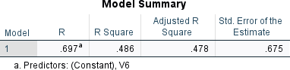

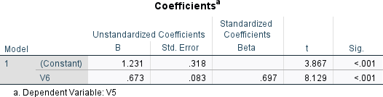

Assume Alpha = 0.05

P-Value = 0.000

Slope = 0.673

Constant = 1.231

Standard Error of Slope = 0.083 Standard Error = 0.675

R-Square =0.486

As P-value<Alpha (0.000<0.05) we reject the null hypothesis.

Therefore, perception of Product Design is Dependent on Materials Used. This implies that if Skechers wants to be known for their product design they should not only have good designs but also quality materials to be able prove that their design is exceptional.

The Regression Equation is Product Design = 1.231 + 0.673(Materials Used)

As R-Square = 0.486, Materials Used Explain 48.6% of the Variance in perception of product design.

# MULTIPLE REGRESSION ANALYSIS

To determine what are the factors that significantly impact the perception of product design, multiple regression analysis needs to be conducted.

The variable chosen were

V6-Materials Used V7-Brand Reputation V8-User Reviews

V9-Warranty/ Guarantee

The Backward Method was used in SPSS to determine which model was significant. Assume Alpha = 0.1

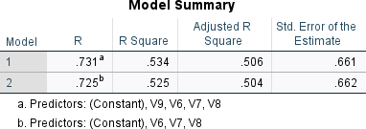

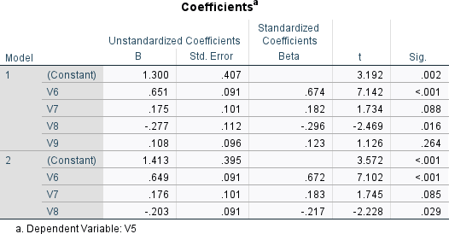

At Alpha = 0.1

Model 2 is significant as all the P-values of the slopes are less than alpha (0.000,0.085,0.029<0.1)

The Regression Equation is

Product Design = 1.413 + .649(Materials Used) + .176(Brand Reputation) -.203 User Reviews Adjusted R-Square = 0.504

This implies that this multiple regression model explains 50.4% of the variance in perception of product design

The Standard Error of the Model is 0.662

# FACTOR ANALYSIS

Factor Analysis is used to uncover the latent structure (dimensions) of a set of variables. Reduces attribution space from a large number of variables to a smaller number of latent factors. It is a non dependent procedure.

To conduct Factor Analysis the Following Variables measured in the metric scale were chosen. When Survey was conducted the respondents were asked to indicate the degree of importance on a 5-point scale where 1 is low importance and 5 is high importance of the following variables on how Loyal the customer is. The variables were as follows

V11-What is the importance of Product Quality on Loyalty of Customer V12-What is the importance of Customer Service on Loyalty of Customer V13-What is the importance of Price and Value on Loyalty

V14-What is the importance of Brand Reputation on Loyalty V15- What is the importance of Variety of Products on Loyalty

# Sample Size

The number of respondents is 72-as it is more than 10 times the number of variables it is an adequate sample size.

# KMO-Bartlett Test

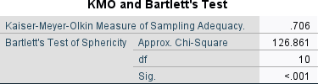

As KMO = 0.706 the sample size is adequate to conduct factor analysis.

As the Bartlett’s Test of Sphericity has a significance level of 0.000 which is less than alpha (0.001), the sample size is significant to conduct Factor Analysis

# Common Method Bias

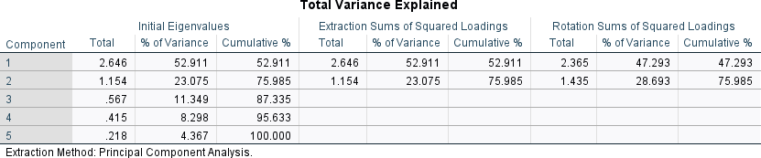

* There are two factors (not a single factor)
* The first factor explains is 47.29% which is less than 50% of the variance

As this meets the requirements of Hermann’s Single Factor Test, there is no Common Method Bias The two factors explain 75.985% of the variance in the variables.

# Factors

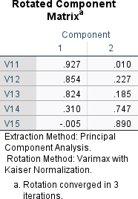

The rotated component matrix is checked for factor loadings as it has been corrected for cross loading.

# Factor 1- V11, V12, V13

**Factor 2-V14, V15**

The names for the two factors are

**Factor 1- CUSTOMER EXPERIENCE FACTOR-** As product quality, customer service and price and value are all variables that determine the loyalty of the customer based on the satisfaction they derive from using the product.

**Factor 2- PRESTIGE FACTOR-**As brand reputation and variety of products are variables that determine loyalty due to the prestige the customer feels by owning or valuing the large number of

offerings of Skechers. It is loyalty derived from being able to show off Skechers Products to others and pride in owning reputed brand products as well as pride in the fact that the brand offers a huge variety of products.

# CLUSTER ANALYSIS

Cluster Analysis Identifies groups of individuals or objects similar to each other but different from other groups to tailor marketing strategies such as segmentation, targeting and positioning.

**Sample Size-**The Sample size is 72 and the number of variables are the same as those used for Factor Analysis which is 5. The sample size is more than ten times the number of variables, therefore cluster analysis can be conducted.

# Hierarchical Analysis

After conducting the hierarchical analysis, the resulting dendrogram is as follows.

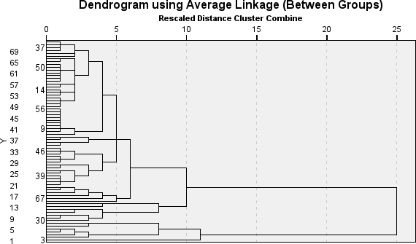

Cutting an Imaginary line between 10 and 15 will result in 2 clusters.

# K-Mean Analysis

After knowing the number of clusters is 2, K-Mean analysis is conducted resulting in the following ANOVA table

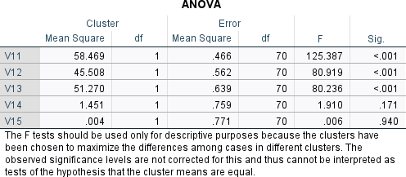

As V14, V15 are not significant at alpha=0.01

K-mean Analysis is conducted again with only significant variables.

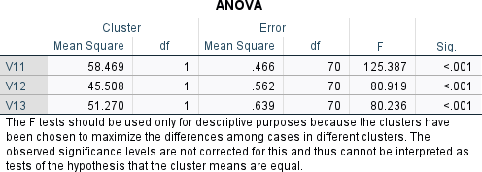

Now all the variables are significant for cluster analysis

# Cluster Membership Cluster 1-

1,2,4,5,6,7,8,9,11,12,13,14,15,16,17,18,19,21,22,23,24,25,26,27,28,29,30,31,32,33,35,36,37,38,39,40,41,

43,44,45,46,47,48,49,50,51,54,55,56,57,58,59,60,61,62,63,64,65,66,67,68,69,70,71,72

# Cluster 2-

3,10,20,34,42,52,53



High- >3 Low-<3

# Cluster 1

High on variables-11,12,13

# Cluster 2

Low on variables-11,12,13

# Names of Clusters

**Cluster 1- Discerning Customers-**Discerning customers are those customers who carefully evaluate and prioritize, product quality, customer service, price and value of commodities when making purchasing decisions

**Cluster 2-Irrational Customers-**Customers whose loyalty does not depend on product quality, customer service, price and value. They are indifferent to the qualities that determine loyalty or rather their loyalty is not determined by rational factors